DECLARATION ESTABLISHING EASEMENT AND PROVIDING MAINTENANCE

THIS DECLARATION establishing a non-exclusive easement and providing a maintenance agreement (hereinafter “Agreement”) is made and entered into this ________ day of March, 2002, by Northpoint Business Park, Inc..

WITNESSETH:

That Northpoint Business Park, Inc., herein referred to as “Declarant”, is the fee simple owner of the real estate located in Huntington County, Indiana, commonly known as tracts “C, D, E-F, G-H & I-J-K”, West Northpoint Avenue, Northpoint Business Park, Huntington, IN, (hereinafter “Tracts”) legal descriptions attached and hereby incorporated into and made a part of this Agreement.

That the Tracts are subject to the following “Easement Area” as defined in the attached Exhibit “A”, that is hereby incorporated into and made a part of this Agreement.

NOW WHEREFORE, in consideration of the mutual terms, covenants and agreements contained herein, Declarant hereby agrees to create an easement and maintenance agreement for “storm water collection, detention and drainage” (hereinafter “Storm Water System”), and “natural wooded space” (hereinafter “Wooded Space”), described as follows:

- That said Easement Area shall be available for free and unencumbered use for Storm Water System, and then as Wooded Space, for the fee simple owners of the Tracts.
- Wooded Space is defined as appearing undisturbed and as close to natural as possible. There shall be no structures or disturbance to the Wooded Space area other than the Storm Water System and that area provided within a certain easement attached as Exhibit “B” that is hereby incorporated into and made a part of this Agreement.
- That the fee simple owners of the Tracts shall share in the perpetual cost and expense of maintaining the Storm Water System in the Easement Area. The cost of maintenance shall be proportional to the area of the land contributing to the Storm Water System.
- That said Storm Water System shall be maintained in good condition at all times. Maintenance and repairs shall include, but not be limited to, cosmetic maintenance, structural maintenance and repairs, mowing, weed control, trash and debris removal, algae & mosquito control, general pond maintenance and safety issues to the Storm Water System. All maintenance will be done so as to assure that all storm water runoff designed to be detained within the basin will be so detained, and the designed rate of runoff will not be increased without the permission of the City of Huntington’s engineering department.
- This maintenance agreement is for the Storm Water System. Maintenance of the Wooded Space is the responsibility of the fee simple owner of that portion of the Easement Area. This includes, but is not limited to, lawn care, landscaping, and tree maintenance within the Wooded Space.
- That should the actions of the fee simple owner of any portion of the Tracts create damage to the Easement Area, that such owner shall be responsible for repair or replacement expenses to restore the Easement Area to at least as good of condition as existed prior to the damage.
- These rights are non-exclusive for use to serve the Tracts.
- That only portions of the Tracts containing a building shall share in maintenance. Damage restoration expenses will be paid by the fee simple Tract owner irregardless of the presence of a building, pursuant to article #6 above.
- That this agreement and the covenants contained herein shall run with the fee simple title to the Tracts, collectively or separately. That the Easement Area, and its rights and obligations, shall endure perpetually.
- This Agreement is made expressly for the benefit of, and shall be binding upon, the heirs, personal representatives, successors in interest and assigns of the respective parties.
- In case any one or more of the provisions contained in this Agreement shall for any reason be held to be invalid, illegal, or unenforceable in any respect, such invalidity, illegality, or unenforceability shall not affect any other provision hereof, and this Agreement shall be construed as if such invalid, illegal, or unenforceable provision had never been contained herein.
- That should a dispute arise, the prevailing party shall be entitled to recover from the loosing party, all legal expenses, including reasonable attorney’s fees, to enforce this Agreement. A lien may be placed on the property for any unpaid common maintenance.
- This instrument contains the entire Agreement between the parties relating to the rights granted and the obligations assumed. Any oral representations or modifications concerning this instrument shall be of no force and effect. Any modification of this Agreement must be in writing and must be signed by the agreeing parties.

_________________________________
Wayne Grigsby - President
Northpoint Business Park, Inc.

STATE OF INDIANA: )
) SS:
COUNTY OF HUNTINGTON: )

The undersigned Notary Public in the State of Indiana, does hereby certify that Wayne Grigsby appeared as President of Northpoint Business Park, Inc. before me this _______ day of March, 2002 and as an act of free will, set forth his hand and acknowledged the execution of the above and foregoing for the uses and purposes herein set forth.

____________________________________
Notary Public

My Commission Expires:_______________________

My County of Residence is: ______________________

This instrument prepared by: Wayne Grigsby-President – Northpoint Business Park, Inc.
9934 Woodland Ridge West, Fort Wayne, IN 46804

Exhibit “A”

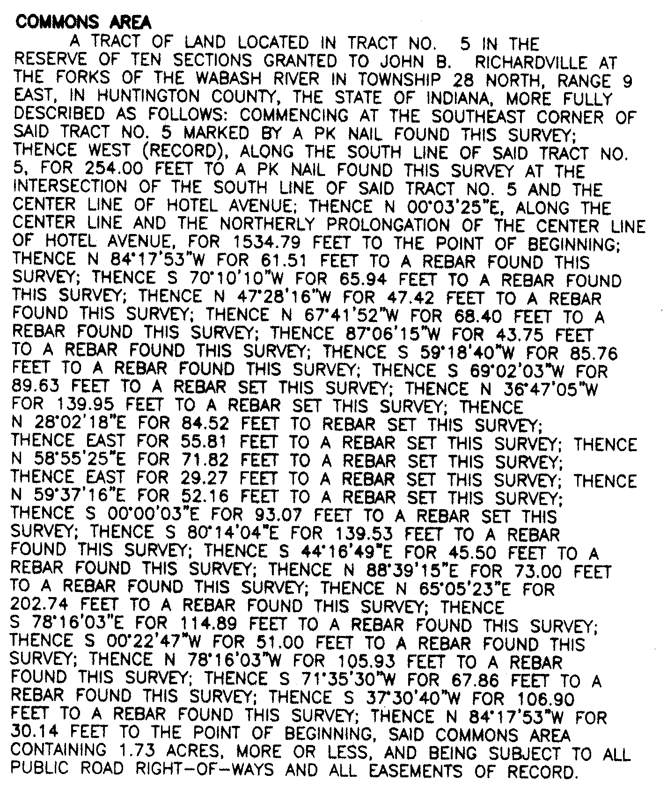

Exhibit “B”

